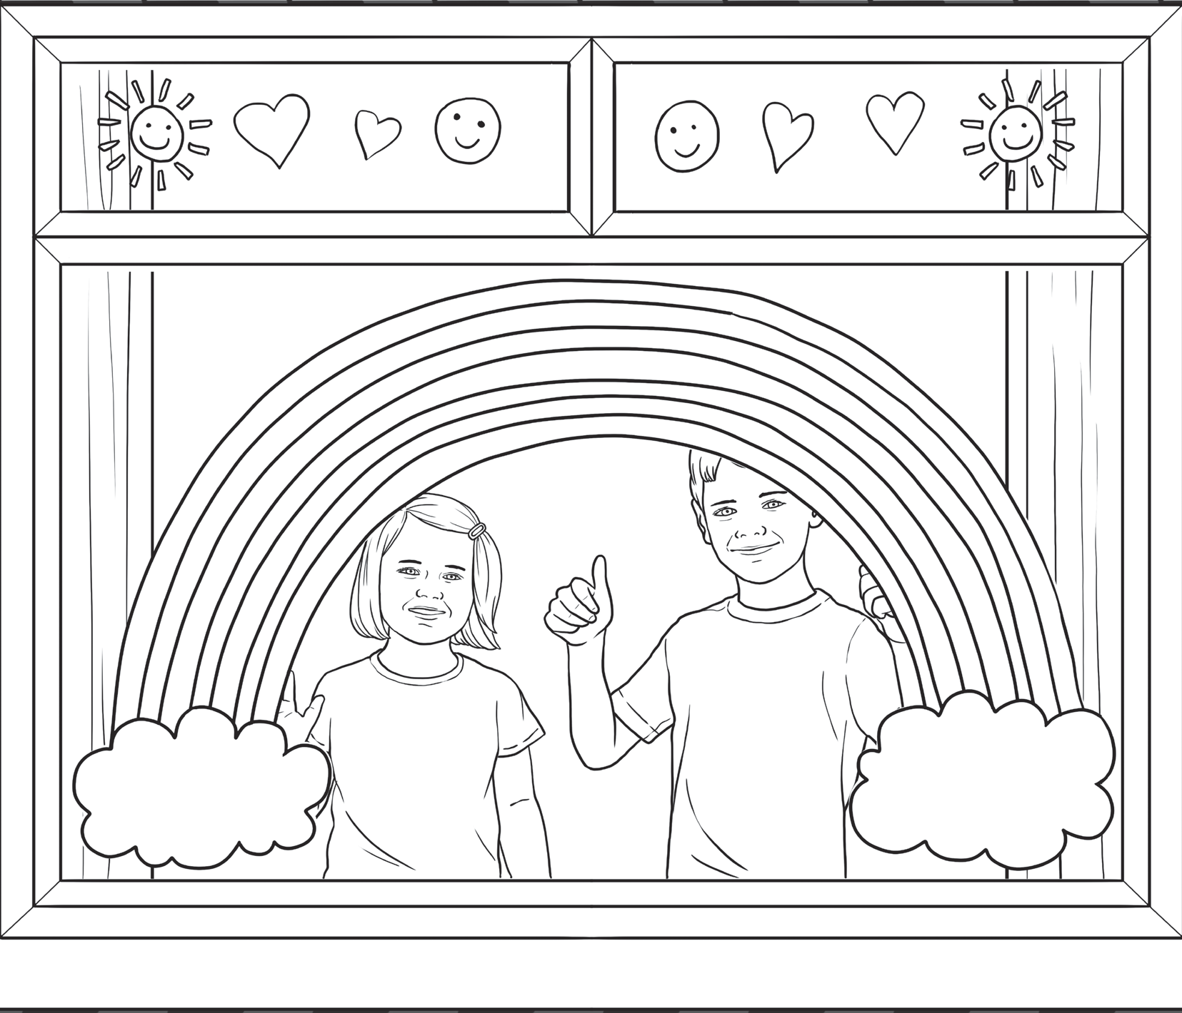

**My Home Learning**

**2020 Time Capsule**

**By**

**visit twinkl.com**



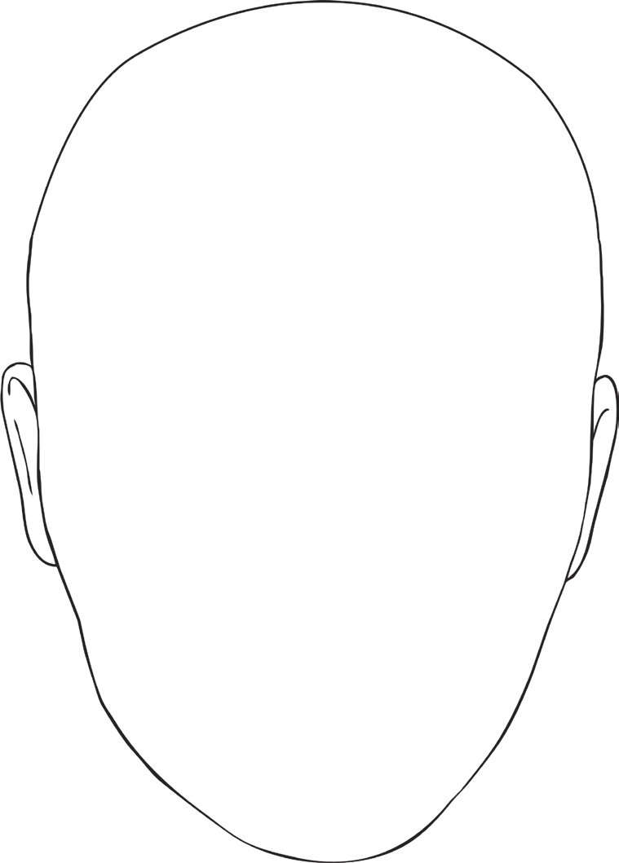

**How I Feel**

**I can’t**

**wait to...**

**Iam**

**thankful for...**

**visit twinkl.com**

**I feel…**



**My Family**

Draw a picture of where you are living.

Draw a picture of who you are living with.

**visit twinkl.com**



**Hands and Paws!**

Can you draw around every family members’ hand on this page? You might like to include pets too. Remember to wash hands before you all do this.

**visit twinkl.com**



**Hands and Paws!**

Can you draw around every family members’ hand on this page? You might like to include pets too. Remember to wash hands before you all do this.

**visit twinkl.com**





**Fun things I’m doing to keep busy.**

**visit twinkl.com**



**Connecting with Others**

How are you staying in touch with friends and family?

Have things in your local area changed? How?

How have things changed around the world?

How are you helping others during this time?

**visit twinkl.com**



**Interview Page**

Choose someone to interview then write down their answers here:

Name

Age

**visit twinkl.com**

How are you feeling?

How many days have you been at home?

How is homeschooling going?

What has been the biggest change so far?

What are you excited to do once this is over?

What are you enjoying most about being at home more?

What are you grateful for?

Will you do anything differently once this is over?