**My Papercraft Filing Box or Fancy Bag**

**What you need for this project**

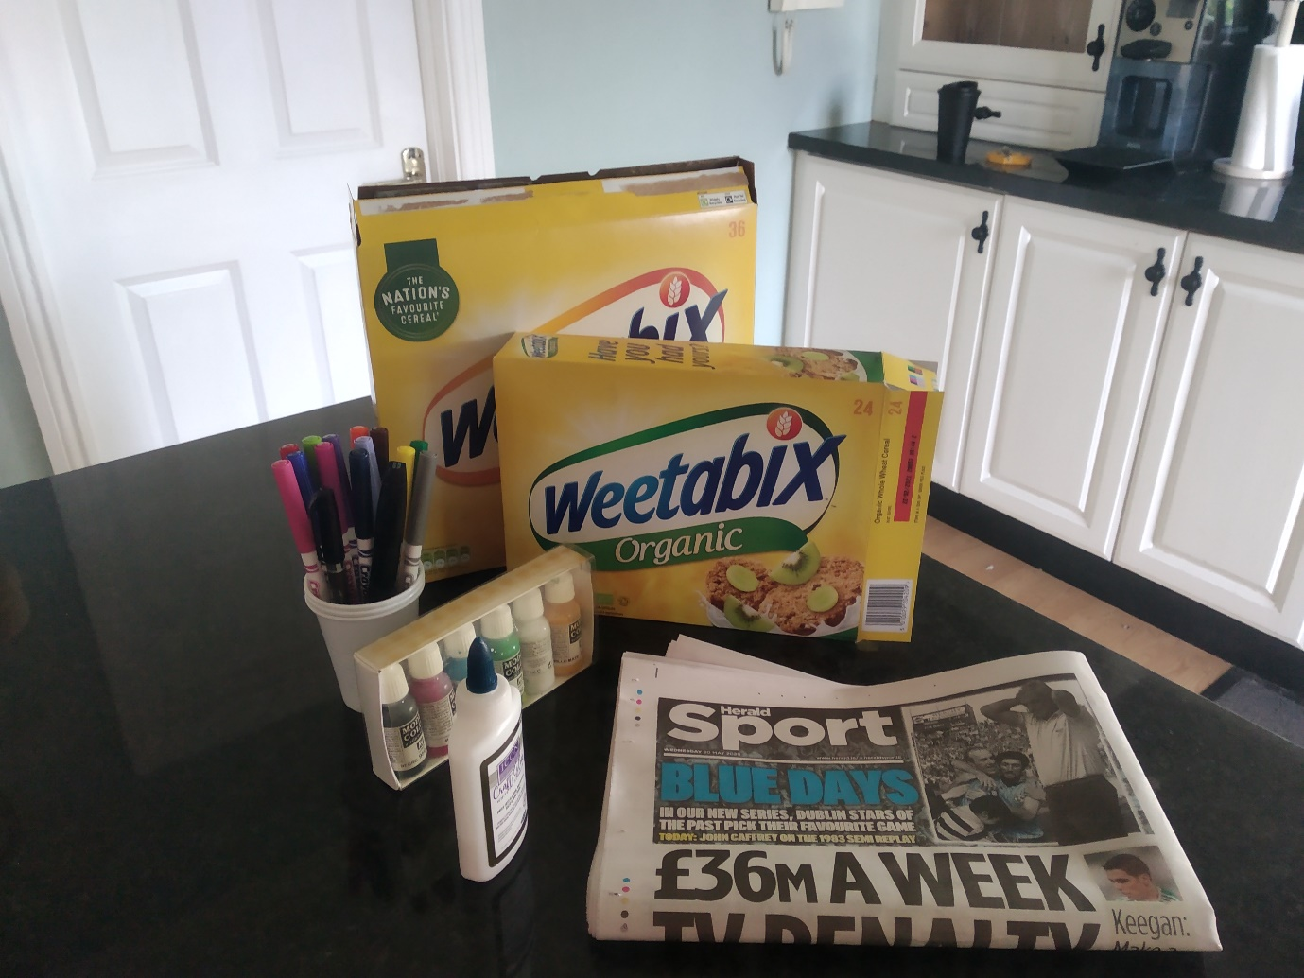

**Empty cereals boxes**

**Markers OR Paints**

**You also need a scissor, a bowl and brush for the glue and a stapler if you want to make the bag.**

**Newspaper**

**PVA Glue**

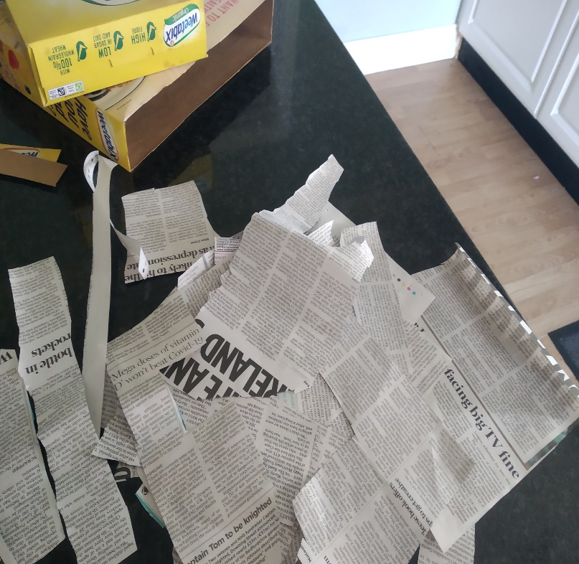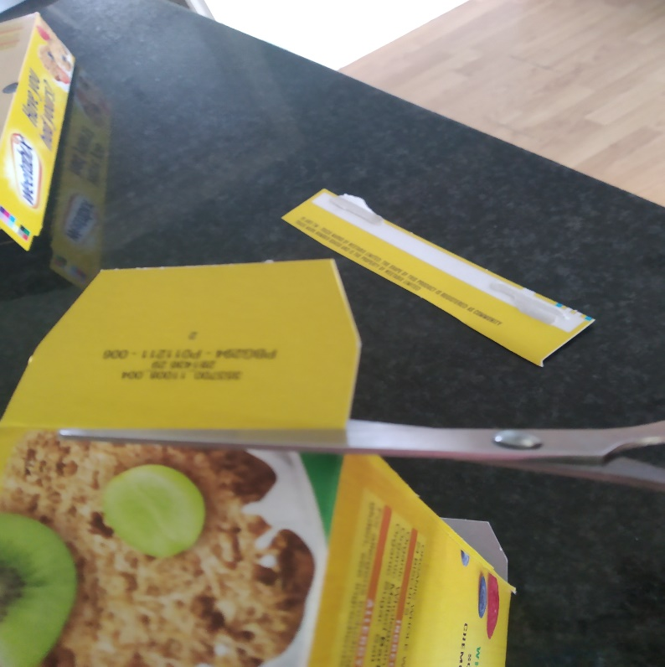

**Tear up the newspaper and use only the black & white print. Do not use coloured print or pictures.**

**Cut off the opening of each box.**

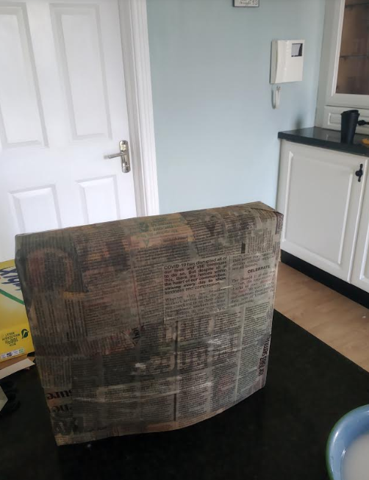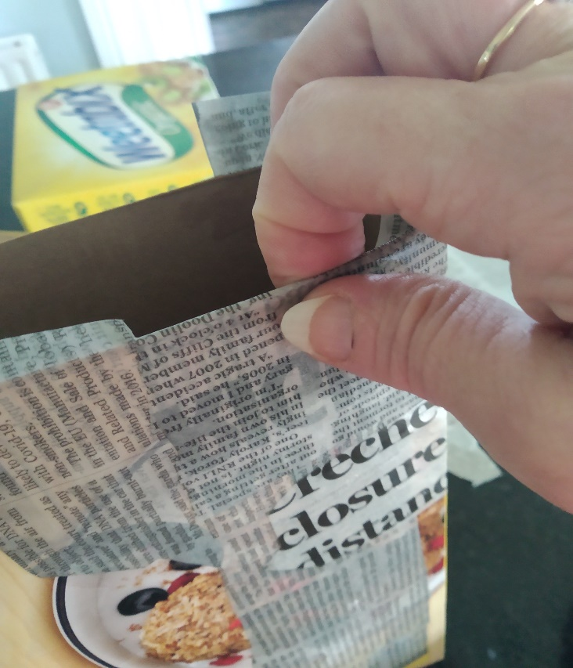

**Let the boxes dry for a couple of hours or overnight.**

**Be sure to fold the wet glued paper over the top opening of each box**

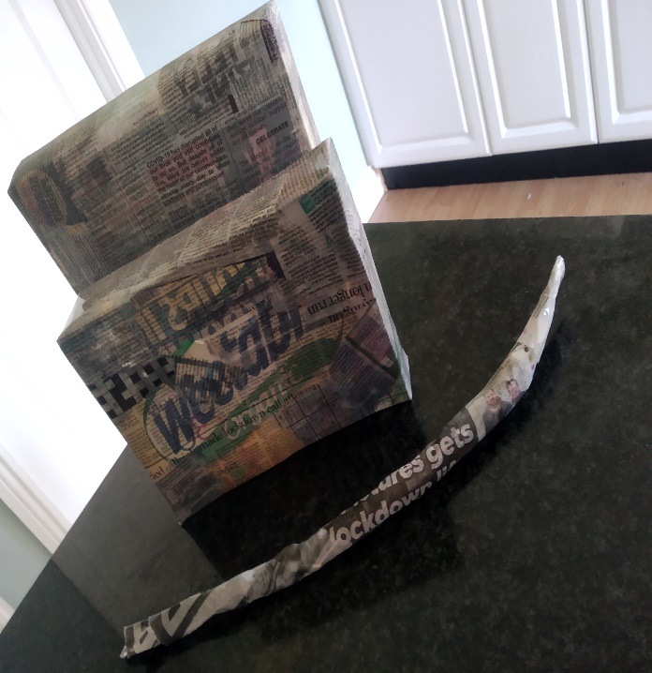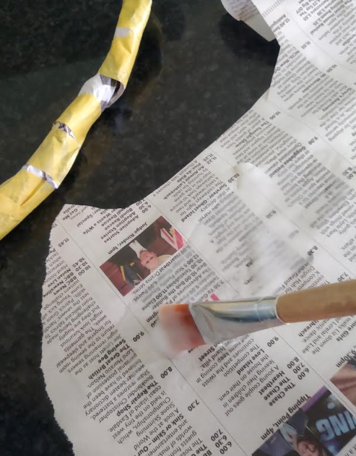

**Wrap the rolled-up paper in tape so it will stay together and make the handle strong. Then cover it in wet glued newspaper for the finish. Let dry.**

**You can make a handle for the bag by rolling up newspaper.**

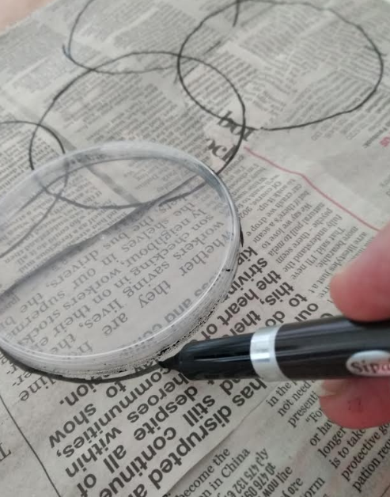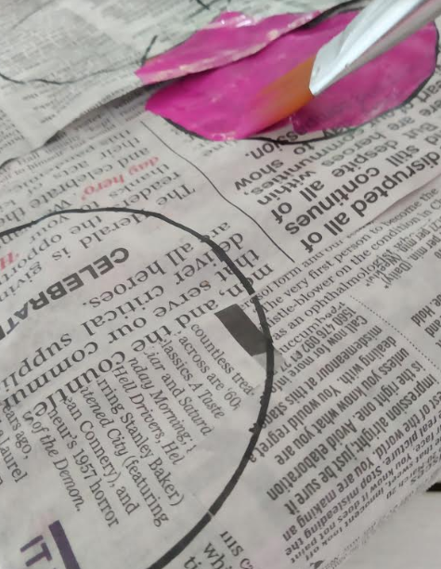

**Use paint or markers to colour your design.**

**When your box is dry, you can decorate with any drawing or shapes. I used the cover of a pringle box to make circles on my box.**

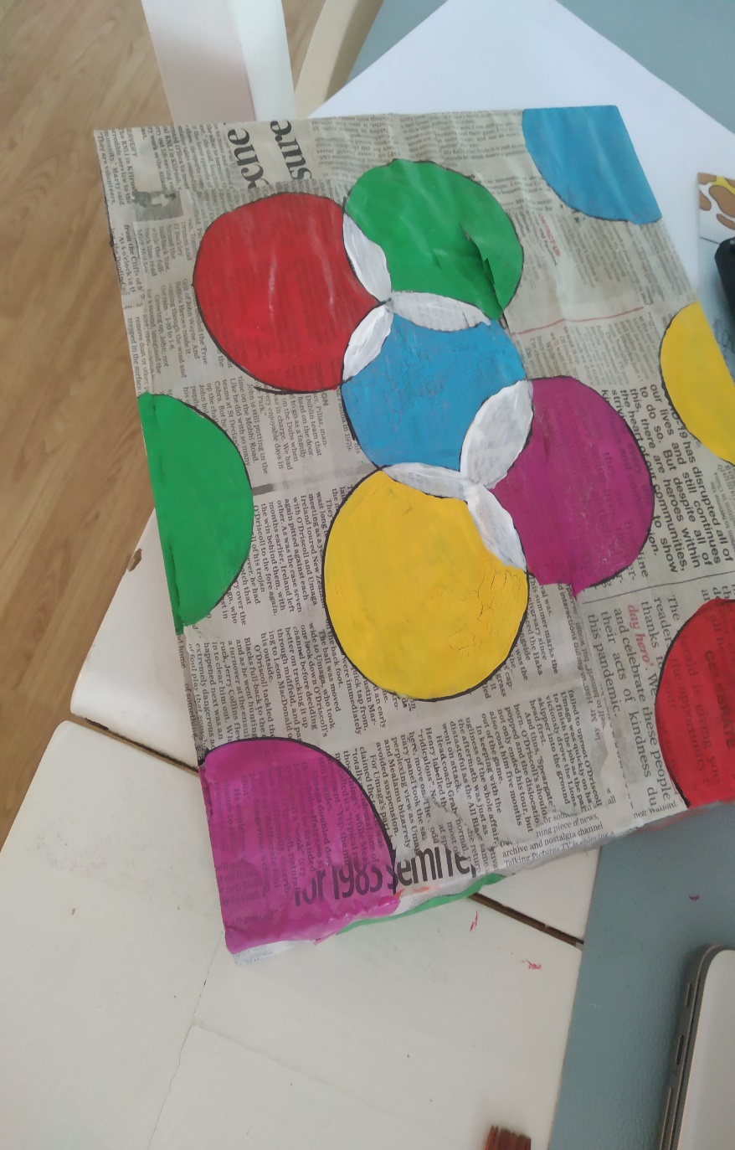

**Outline your drawings again in black marker after the paint has dried.**

**Here are my designs on my boxes**

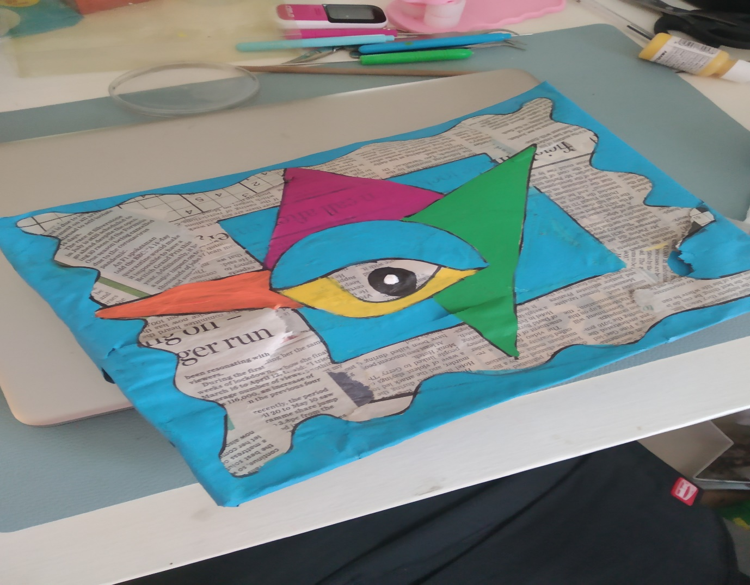

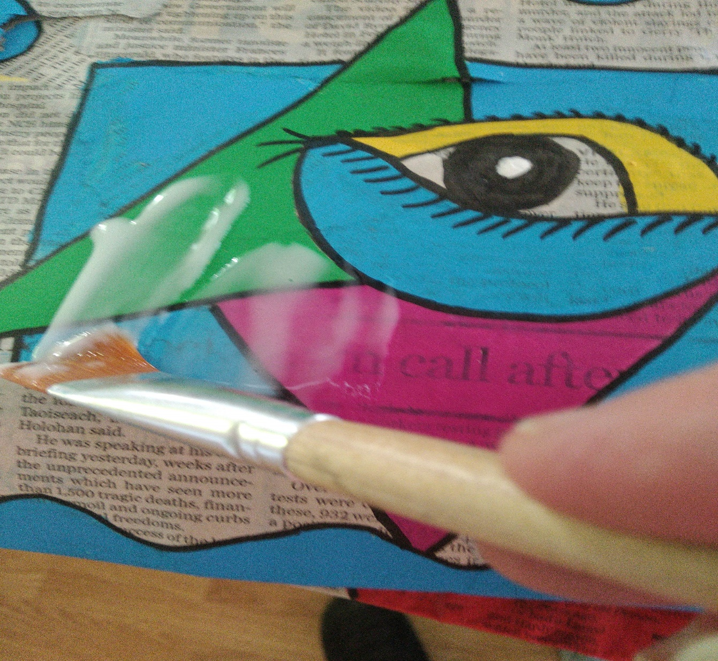

**When your paint has dried. Cover it with plenty of PVA glue or spray with clear varnish if you have it. Either the pva glue or the varnish will seal and protect your paint and make your box stronger when dry. It also gives a beautiful shine to your boxes.**

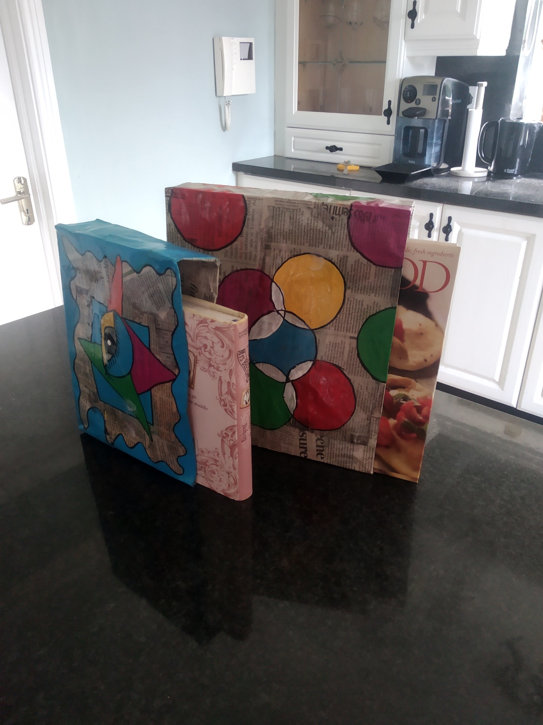

**What do you think of my filing boxes for my cookery books?**

**Aren’t they just cool!**

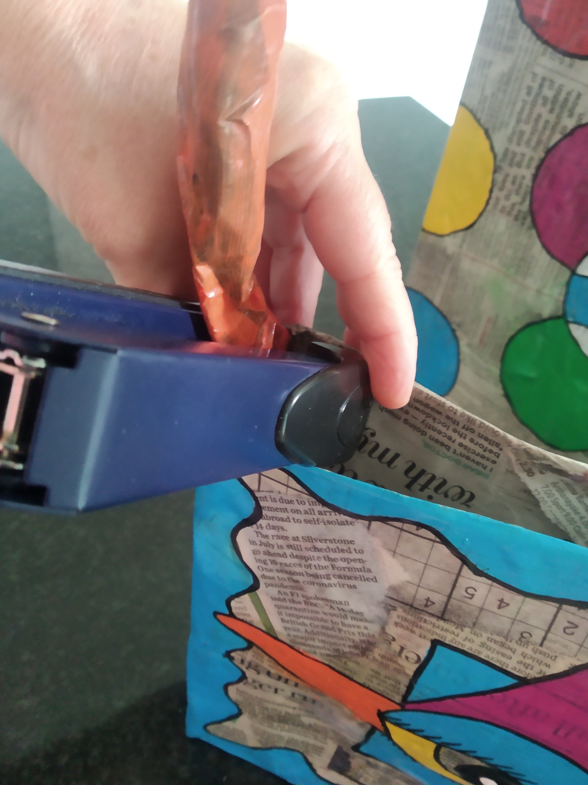

**The smaller box can be turned into a fancy bag by just stapling the handle to each side. Look at picture below.**

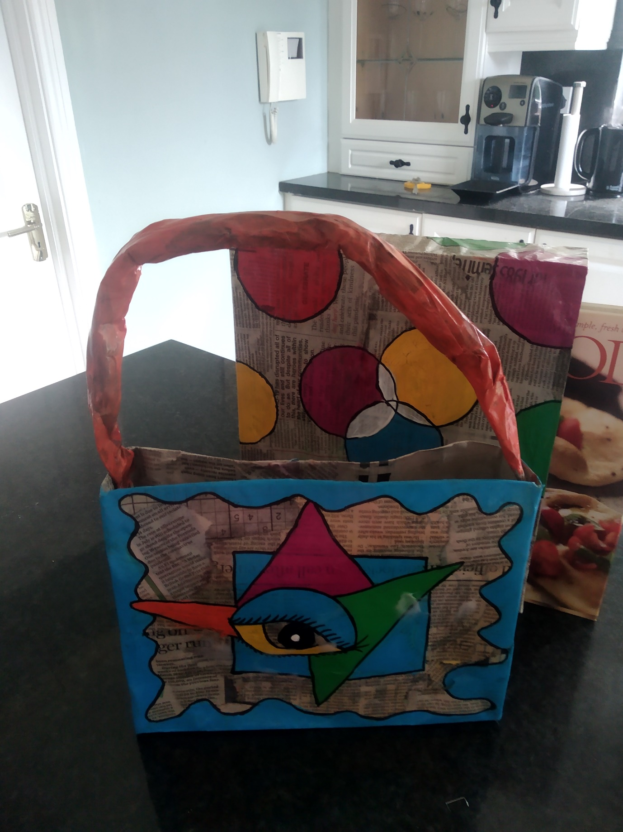

**My Fancy Bag and Filing Box**