Class Level: 4th Class
Hi girls, we’ve made it to June!
We are lessening the workload on you all because we would be easing down to the summer holidays in June if we were still in school. Do not worry that there is less to do, you have done your very best since March and we are so happy with you all.
We have given you spellings which you can find if you scroll down below. We have also given you Maths from Action Maths, we have included this work at the end of this document.
We would really like you to get out and enjoy the weather and spend time in nature, you could even do your DEAR time outside in the sunshine!
You can send us photographs of your daily tasks or any work you’d like to show us that you’re proud of, we would love to see it! Please send it from a PARENT’S email during school hours to msbehan.olv@gmail.com or ms.jsmitholv@gmail.com .
All the best,
Ms Behan & Ms Smith & Ms Hanly

 | Tuesday 2nd June | Wednesday 3rd June |  | Thursday 4th June |  | Friday 5th June
Gaeilge | Every day, please spend 15-20 minutes practicing your Gaeilge using some of the suggestions on the online resources section of the website.  http://www.olvgns.ie/gaeilge-resources.html
English | EIP  DEAR time 15mins  Spellings  Correct EIP (see answers on blog) | EIP  DEAR time 15mins  Spellings  Correct EIP (see answers on blog) |  | EIP  DEAR time 15mins  Spellings  Correct EIP (see answers on blog) |  | EIP  DEAR time 15mins  Spellings  Correct EIP (see answers on blog)
Ms Hanly’s English Group | Spellings:  Correct, Earthquake.  Reading: Read as much as you can today, maybe one paragraph!  Write: Make note of just one new word.  https://www.storynory.com/helen-of-troy/ | Spellings:  Bookshelf, Plural.  Reading: Read as much as you can today, maybe one paragraph!  Write: Make note of just one new word.  https://www.storynory.com/helen-of-troy/ |  | Spellings:  Ripen, Sprawled.  Reading: Read as much as you can today, maybe one paragraph!  Write: Make note of just one new word.  https://www.storynory.com/helen-of-troy/ |  | Spellings:  Division, Backpack.  Reading: Read as much as you can today, maybe one paragraph!  Write: Make note of just one new word.  https://www.storynory.com/helen-of-troy/
Maths | Mental Maths  Action Maths Sheet pg. 17 Q. 1-3  Challenge (to try if you’d like): Q. 4-6  Correct Mental Maths (See answers on blog) | Mental Maths  Action Maths Sheet pg. 17 Q. 10  Challenge (to try if you’d like): Q. 7-9  Correct Mental Maths (See answers on blog) |  | Mental Maths  Action Maths Sheet pg. 17 Q. 11  Challenge (to try if you’d like): Q. 7-9  Correct Mental Maths (See answers on blog) |  | Mental Maths  Action Maths Sheet pg. 17 Q. 12 (a-f)  Challenge (to try if you’d like): Q. 12 (g-j)  Correct Mental Maths (See answers on blog)
Ms Hanly’s Maths Group | Mental Maths Continued.  Don’t forget to correct them!  Maths Game!  https://www.coolmath4kids.com/math-games/grand-prix-multiplication | Mental Maths Continued. Don’t forget to correct them!  Maths Game!  https://www.coolmath4kids.com/math-games/alien-addition |  | Mental Maths Continued. Don’t forget to correct them!  Maths Game!  https://www.coolmath4kids.com/math-games/demolition-division |  | Mental Maths Continued. Don’t forget to correct them!  Maths Game!  https://www.coolmath4kids.com/math-games/island-chase
SPHE | Check the website for a well-being task set by a different teacher every day.  http://www.olvgns.ie/daily-task.html
Daily Activity | Ms Cassidy’s Music |  | Ms Farrell’s Science |  | Ms Behan’s History |  | Ms O’Dea’s P.E.

 | Monday 8th June | Tuesday 9th June |  | Wednesday 10th June |  | Thursday 11th June |  | Friday 12th June
Gaeilge | Every day, please spend 15-20 minutes practicing your Gaeilge using some of the suggestions on the online resources section of the website.  http://www.olvgns.ie/gaeilge-resources.html
English | EIP  DEAR time 15mins  Spellings  Correct EIP (see answers on blog) | EIP  DEAR time 15mins  Spellings  Correct EIP (see answers on blog) |  | EIP  DEAR time 15mins  Spellings  Correct EIP (see answers on blog) |  | EIP  DEAR time 15mins  Spellings  Correct EIP (see answers on blog) |  | EIP  DEAR time 15mins  Spellings  Correct EIP (see answers on blog)
Ms Hanly’s English Group | Spellings:  Politics, Workout.  Write:  Write out these sentences properly….  I HOPE IT DOESN’T RAIN/REIN  Missing Vowels:  Every tre_ in a r_inforest is fo_d, shelter and hom_ to lots of an_mals. | Spellings:  Attic, Microwave.  Write:  Write out these sentences properly….  TURN RIGHT/WRITE AT THE JUNCTION  Missing Vowels:  Moles and r_dents dig am_ng the ro_ts. |  | Spellings:  Calculator, Perfect.  Write:  Write out these sentences properly….  WE WALKED TO THE BEECH/BEACH  Missing Vowels:  Woodpeck_rs p_ck at the b_rk for _nsects. |  | Spellings:  Weekend, Confused.  Write:  Write out these sentences properly….  THEY HAD THERE/THEIR LUNCH  Missing Vowels:  Sn_kes slith_r through the br_nches and le_pards drag the_r food to th_ fork of a tree tr_nk. |  | Spellings:  Contract, Broomstick.  Write:  Write out these sentences properly….  WHERE/WEAR IS THE EXIT DOOR?  Missing Vowels:  Larg_ creatures such as b_rds and mamm_ls will come _nd go.
Maths | Mental Maths  Action Maths Sheet pg. 25 Q. 1-3  Challenge (to try if you’d like): Q. 7  Correct Mental Maths (See answers on blog) | Mental Maths  Action Maths Sheet pg. 25 Q. 1-3  Challenge (to try if you’d like): Q. 8  Correct Mental Maths (See answers on blog) |  | Mental Maths  Action Maths Sheet pg. 25 Q. 4  Correct Mental Maths (See answers on blog) |  | Mental Maths  Action Maths Sheet pg. 25 Q. 5  Correct Mental Maths (See answers on blog) |  | Mental Maths  Action Maths Sheet pg. 25 Q. 6  Correct Mental Maths (See answers on blog)
Ms Hanly’s Maths Group | Mental Maths continued. Don’t forget to correct!  More Maths Games!  https://www.coolmath4kids.com/math-games/dirt-bike-fractions | Mental Maths continued. Don’t forget to correct!  More Maths Games!  https://www.coolmath4kids.com/math-games/jet-ski-addition |  | Mental Maths continued. Don’t forget to correct!  More Maths Games!  https://www.coolmath4kids.com/math-games/weighing-fruits?tid=1 |  | Mental Maths continued. Don’t forget to correct!  More Maths Games!  https://www.coolmath4kids.com/math-games/meteor-multiplication |  | Mental Maths continued. Don’t forget to correct!  More Maths Games! (I’ve given you yesterdays one again, because I think it’s fun and helpful!).  https://www.coolmath4kids.com/math-games/meteor-multiplication
SPHE | Check the website for a well-being task set by a different teacher every day.  http://www.olvgns.ie/daily-task.html
Daily Activity | Ms Holden’s Art |  | Ms Farrell’s Drama |  | Ms Haughton’s P.E. |  | Ms Smith’s Art |  | Ms Bourke’s Geography

Spellings Week 1: <nch> | Spellings Week 2: Plurals with <ves>
Daisy 1-6, Tulip 1-12, Rose 1-18  - winch  - drench  - quench  - stench  - hunch  - lunchbox  - scrunch  - rancher  - flinch  - wrench  - crunchy  - pinched  - launch  - franchise  - henchmen  - enchantment | Daisy 1-6, Tulip 1-12, Rose 1-18  - scarves  - selves  - wives  - lives  - elves  - loaves  - hooves  - leaves  - knives  - wolves  - shelves  - halves  - calves  - thieves  - ourselves  - themselves

Week 1: Action Maths pg 17
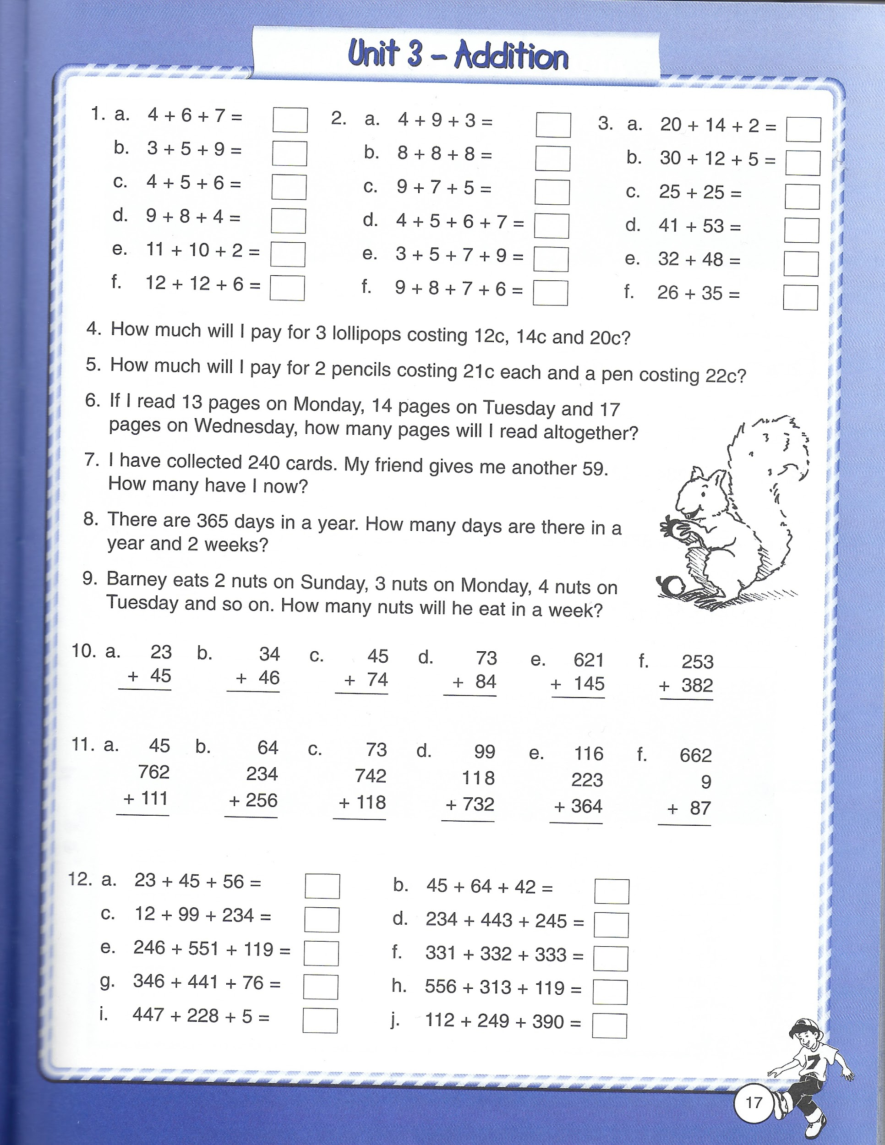

Week 2: Action Maths pg. 25
