Maths | Topic | Mental Maths | IXL | Other
1st - 5TH June 2020 | Capacity | Week 34  Pages  101 - 103  Remember to use rough worksheets to work out your sums and don’t forget to use TOUCH MATHS POINTS  Keep up the Friday Tests if you can. | H 1  O 1 | Look at the pictures below:  Read and answer questions orally.  Experiment with lots of different containers with the help of Mam and Dad and HAVE FUN.

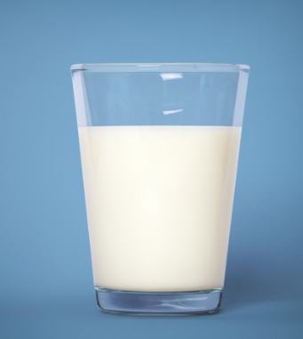
Maths: Capacity (Oral and visual work)
- How do you measure the milk in this glass?

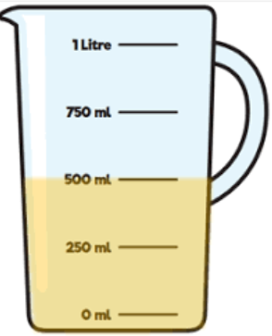
We use a measuring jug.
- Can you see the numbers on the jug?
- Can you see the letters where the arrows are pointing?
- Can you name the letters?
- We measure liquid in millilitres and Litres.
- How many millilitres is the liquid in the jug at?
- How many millilitres does it take to fill this jug?
- How many millilitres makes one litre?

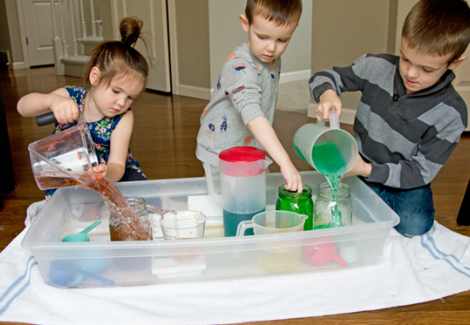
Work to do
- Get your jug and an empty cup and basin.
- Pour one cup of water into the jug.
- Look where the liquid stopped in the jug.
- Can you see the number where it stopped?
- Now pour two cups of water into the jug.
- What number did the liquid stop at?
- Now use an egg cup of water instead of a cup.
- Can you see the difference in the amount of liquid?
- Now try lots of different size containers and measure the amount of liquid.
Ask your mam or dad to add food colour to the water and have more fun.

Maths | Topic | Mental Maths | IXL | Other
8th – 12th June 2020 | Perimeter | Week 35  Pages  104 - 106  Remember to use rough worksheets to work out your sums and don’t forget to use TOUCH MATHS POINTS  Keep up the Friday Tests if you can. | H 2  O 4 | Look at the pictures below.  Read, answer and do on each worksheet.
- Perimeter is the distance around the outside of a shape.
- Perimeter is found by adding together the length of all a shape's sides.

Can you measure each side of this shape and add them together to find the Perimeter?.

Answer =

Work to do:

Look at each of the following items. Take your ruler and measure the 4 sides of the chocolates, crackers and the cornflakes in centimetres. Write your answer in the box beside each picture. Don’t forget to write the letters cm next to your number.

