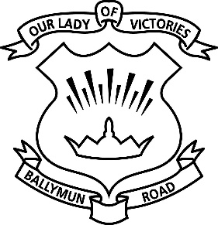
4th August 2020
RE: Re-opening of OLV Girls’ School

Dear Parents/Guardians and Staff Members,
I hope you and your families are keeping well.
As you are aware, our school has now been closed since 12th March due to the COVID-19 situation. We are now hoping to re-open our school safely, in line with current guidance and recommendations.
We intend to reopen as scheduled on August 27th for all children.
Re-opening the school safely will require the co-operation of all members of our School Community – BoM, School Leadership, Staff, Parents and Pupils. We will all be called on to play our part in ensuring that re-opening of the school is done in a safe manner which prevents the spread of the virus and allows the vital work of Teaching and Learning to proceed with as little disruption as possible.
We have been working on our plan for the safe reopening of the school for some weeks now and have published the DES COVID-19 Response Plan for the safe and sustainable reopening of Primary and Special Schools on our school website.
The Response Plan gives details of
- Physical preparation, signage, hand sanitiser stations,
- Advice, procedures and training for the safe return to working in the school for all school staff and pupils
- General and specific advice on how all pupils, staff, parents and visitors will prevent the spread of the virus
We have also published our COVID-19 Policy Statement on the school website. Our BoM will keep you informed as to the progress of our re-opening plans and provide you with the information required by you to play your part in safely re-opening the school.
The following websites provide further information on COVID-19 and on government advice and recommendations regarding the re-opening of schools: -
- https://www.education.ie/en/covid-19/
- https://www2.hse.ie/coronavirus/
- https://www.gov.ie/en/campaigns/a128d-back-to-school/?referrer=http://www.gov.ie/backtoschool/

RE: Physical Distancing and Safe School Attendance
We are currently working on upgrading our procedures and routines within the school to ensure that there is as much Physical Distancing as is possible in our building. We will apply physical distancing in a practical and sensible way, recognising that the learning environment cannot be dominated by a potentially counterproductive focus on this issue.
Physical Distancing will be achieved in two ways: -
Increasing Separation. This will be achieved by re-configuring the classrooms to maximise physical distancing. Each class will be referred to as a bubble and we will ensure that there is as little contact as possible between children in different bubbles. Within the bubbles, children will be organised into pods. A pod is a group of children (normally 6) who will sit together and who will stay in their pod while in the bubble, or classroom.
Decreasing Interaction. This will be achieved by decreasing the potential for children from different bubbles to interact. There will be marked routes for various bubbles to enter and exit the school and to access their classrooms. Bubbles will have different mid-morning and lunch-time access to the playground. We will make these routines enjoyable activities for the children, emphasising safety at all times.
While all children will be welcome back to school, we would remind parents that, where children are displaying colds, coughs or flu like symptoms, they should not be sent to school. Children who display such symptoms in school will be isolated and parents asked to collect them from the school.
Children who have travelled from countries not on the Green List should not attend school during the 14-day self-isolation period
Further information on COVID-19 symptoms in children is available at: -
https://www2.hse.ie/conditions/coronavirus/if-your-child-has-symptoms.html
Teachers will make children aware of the proper hygiene procedures regarding hand washing and etiquette related to sneezing, coughing or spitting. We would be grateful if you could also emphasise safe behaviour in this regard to your children at home as part of the preparation for returning to school.
Our aim remains to re-open the school in an orderly safe manner, while reassuring the children and making them feel comfortable, safe and relaxed with their friends in the new school environment. This will be achieved by all of us working towards this common goal.
We are really looking forward to welcoming our children back to school and will be doing all that we can to ensure that the return to school is a safe and enjoyable experience for the children. We will be in touch with you again before school re-opens.

Your Sincerely,

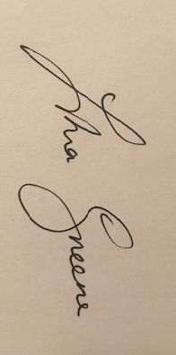
Principal

