Class Level: 3rd Class
 | Tuesday 2nd June | Wednesday 3rd June | Thursday 4th June | Friday 5th June
Gaeilge | Every day, please spend 15-20 minutes practicing your Gaeilge using some of the suggestions on the online resources section of the website.  http://www.olvgns.ie/gaeilge-resources.html
English | Spellings (Learn and put into sentences)  - Knee  - Know  - Knot  - Knock  One day in EIP  Better English pg 73  Animal Antics  Read the poems and answer questions in your copy | Spellings (Learn and put into sentences)  - Knight  - Knowledge  - Gnome  - Gnash  One day in EIP  Better English pg 68  Contractions  Complete questions in copy | Spellings (Learn and put into sentences  - Sign  - Reign  - Design  - Foreign  One day in EIP  Biographies/ Autobiographies – Week 1 – Day 1  This week we are going to learn what a biography is. Page 1 of the attached document will give you a clear description. | Spelling Test  One day in EIP  Biographies/ Autobiographies – Week 1 – Day 2  On pages 2 and 3 you will find an example of a biography, all about Roald Dahl.  Read this biography and create a fact file, detailing the main points you learned.
Ms. Fleming’s English Group | 1. Spellings: take, thank  2. Read aloud: kind, laugh, long light, much, only myself, never  3. Rhyming lists. BALL: fall, tall  4. Make new words! Example: St – stay, stray Now try Tr-try, tree  5. Reading: www.starfall.com Click onto Grades 1,2,3- “I’m reading”, “Fiction and non-fiction”, “I can do it” p. 10-13 | 1. Sp: them, then  2. Read aloud: own, pick, start seven, shall, six, show, small  3.Rhyming Lists:  SAD: mad, glad  4. Make new words: Dr -dry  5. www.starfall.com “I’m reading”, “Fiction and non-fiction”, “I can do it” p.14-17 | 1. Sp: think, walk  2. www.starfall.com “I’m reading”,“Fiction and non-fiction”, “I can do it” p.18-21  3. IXL! | 1. Spelling test! Good luck!  2. Read aloud: ten, today, try, together, warm, apple, baby, back  3. Rhyming Lists:  BAG: flag, tag  4. Make new words: Tw-twig  5. www.starfall.com “I’m reading” “Fiction and non-fiction”, “I can do it” p. 22-26
Ms Malone’s English Group | Find these words in the wordsearch below:  swimming, spinning, getting, letting, patting, planning, sledding, clapping, winning, sitting, beginning, running, hopping, tripping, popping.  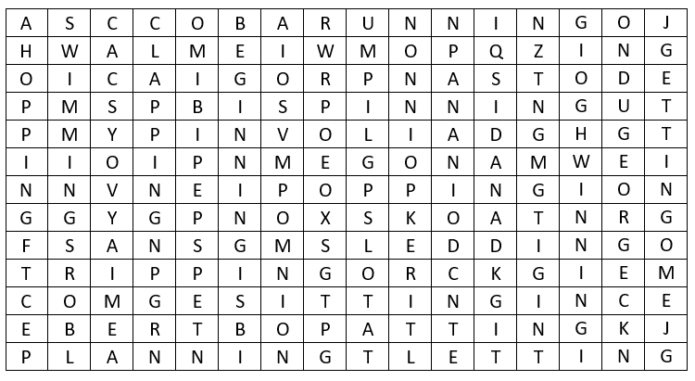 | Read Gemma Chapter 8  https://www.freechildrenstories.com/gemma | Play the following hangman game:  https://www.turtlediary.com/game/body-parts-hangman.html | Try the following game  https://www.education.com/game/homerow-f-j-d-k-s-l-keys/
Maths | Topic: Patterns  BAM pg 147  MM week 34  Mon + Tues | Topic: Patterns  BAM pg 148 + 149  MM week 34  Wednesday | Topic: Patterns  BAM pg 150  MM week 34  Thursday | Topic: Patterns  Get creative.  Design your own patterned socks or maybe even a  t-shirt.  MM week 34  Friday review
SPHE | Check the website for a well-being task set by a different teacher every day.  http://www.olvgns.ie/daily-task.html
Daily Activity | Ms Cassidy’s Music Activity | Ms Farrell-McCabe’s Science Activity | Ms Behan’s History Activity | Ms O Dea’s PE Activity

 | Monday 8th June | Tuesday 9th June | Wednesday 10th June | Thursday 11th June | Friday 12th June
Gaeilge | Every day, please spend 15-20 minutes practicing your Gaeilge using some of the suggestions on the online resources section of the website.  http://www.olvgns.ie/gaeilge-resources.html
English | Spellings (Learn and put into sentences)  - Phone  - Photo  - Graph  One day in EIP  Better English pg 97  Two friendly cows  Read the poems and answer questions in your copy | Spellings (Learn and put into sentences)  - Dolphin  - Elephant  - Alphabet  One day in EIP  Better English pg 76  Conjunctions  Complete questions in copy | Spellings (Learn and put into sentences)  - Laugh  - Rough  - Tough  One day in EIP  Biographies/ Autobiographies Week 2 – Day 1  Read the biography of Ed Sheeran. Create a fact file summarising what you learned. Is there anything else you can add? | Spellings (Learn and put into sentences  - Enough  - Cough  - Trough  One day in EIP  Biographies/ Autobiographies Week 2 – Day 2  Read the biography of Ariana Grande. Create a fact file summarising what you learned. Can you add in some other facts? | Spelling Test  One day in EIP  Biographies/ Autobiographies Week 2 – Day 3  Use the same structure as the two biographies you read on Wednesday and Thursday to create your own biography of your favourite celebrity.
Ms. Fleming’s English Group | 1. Spellings: were, when  2. Read aloud ball, bear, box, boat bed, bell, bird, birthday  3. Alphabetical Order: peas, beans, tuna, corn,  4. Capital letters: today baby kate ate her egg  5. Reading: www.starfall.com Click onto Grades 1,2,3- “I’m reading”, “Fiction and non-fiction”, “The no-tail cat or I like what I am” p. 2-5 | 1. Spellings: always, around. 2. Read aloud: boy, bread, brother, cake, car, cat, chair, chicken,  3. Alphabetical order: tomatoes, salmon, chickpeas, black-beans  4. Capital letters: “thank you for my new coat” said ann.  5.Reading: www.starfall.com “The no-tail cat or I like what I am” p. 6-10 | 1. Spellings: been, because  2. Read aloud: children, Christmas, coat, corn, cow, day, dog, doll,  3. Alphabetical Order: ketchup, mayonnaise, curry paste, brown sauce  4.Capital letters: mommy bought a magazine called hello  5. Reading: www.starfall.com “The no-tail cat or I like what I am” p. 11-15 | 1. Spellings: best, before  2. Reading: www.starfall.com “The no-tail cat or I like what I am”p.16-20  3. IXL | 1. Spelling Test  2. Read aloud: door, duck, egg, eye, farm  3.Alphabetical order: chocolate, popcorn, sweets, banana  4. Reading: www.starfall.com “The no-tail cat or I like what I am” p.21-26
Ms Malone’s English Group | Do the crossword!!  https://lovattspuzzles.com/kids/childrens-online-puzzles/spellbound/ | Read Gemma Chapter 9  https://www.freechildrenstories.com/gemma | Play hangman here  https://www.turtlediary.com/game/colors-labeling.html | Play hangman here:  https://www.turtlediary.com/game/animals-labeling.html | Play the game:  https://www.roomrecess.com/games/SlimeLab/play.html
Maths | Topic: Money  BAM pg 144  MM week 35  Monday | Topic: Money  BAM pg 145  MM week 35  Tuesday | Topic: Money  BAM pg 146  MM week 35  Wednesday | Topic: Money  Create the shopping list for your family this week.  Estimate the prices of the products on your list.  Total your list to see how much it will cost.  MM week 35  Thursday | Topic: Money  Review the shopping list you created yesterday.  Can you make any changes to try and reduce the total cost?  Are there any non-essential items you could take off the list?  MM week 35  Friday review
SPHE | Check the website for a well-being task set by a different teacher every day.  http://www.olvgns.ie/daily-task.html
Daily Activity | Ms Holden’s Art Activity | Ms Farrell’s Drama Activity | Ms Haughton’s PE Activity | Ms Smith’s Art Activity | Ms Bourke’s Geography Activity

